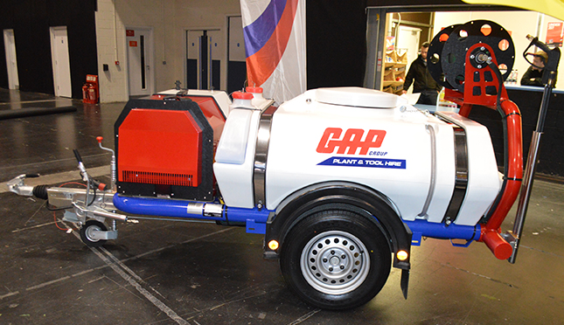
Case Study – Super Silent Pressure Washer
GAP's vision is to be the UK's most innovative hire solutions provider. As a family business operating in the hire sector for over 50 years, we understand that our customer's needs are constantly changing. We want to be at the forefront of better solutions that meet those needs.

The Super Silent Pressure Washer has dramatically minimised noise pollution from cleaning operations on the Thames Tideway Tunnel project. The product was successfully delivered through GAP’s willingness to invest in innovative eco-products and through our partnerships and collaboration with market leading manufacturers.

Introduction

GAP Hire Solutions, the UK’s largest independent equipment provider, collaborated in partnership
with Costain, VINCI Construction Grands Projets and Bachy Soletanche (CVB Joint Venture) and
Brendon Powerwashers to develop the innovative Super Silent Pressure Washer – a powerful yet
quiet pressure washer, which adheres to the conditions of the Control of Pollution Act 1974.

Project / Scope Overview:

CVB JV are the main works contractor for the east section of the Thames Tideway Tunnel.
Construction work for the new 25-kilometre interception, storage and transfer tunnel running up to
65 metres below the river, started in 2016 and will be an upgrade to the London sewerage system to cope with the demands of the city well into the 22nd century. Under Section 61 of the Control of
Pollution Act 1974, construction contractors are legally required to keep noise pollution to a
minimum.

Innovative product designed and delivered in 6-months

CVB approached Brendon Powerwashers for the development of a silent alternative to the standard
pressure washer who designed and costed their new “Quietec” Range.

GAP were then approached by CVB with the offer of investing in the product and are now proud to be the first hire company to have invested in a Super Silent Pressure Washer.

At GAP, we are committed to becoming the UK’s most innovative hire solutions provider. Our
company is driven to innovate and collaborate, with a focus on providing environmentally friendly
and efficient hire solutions to our customers.

The Super Silent Pressure Washer has proven such a success that CVB ordered an additional nine
units to be deployed across their Tideway work sites.
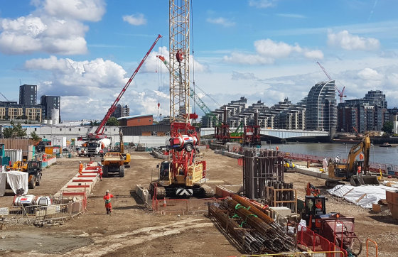
Super Silent Pressure Washer getting moved by a crawler crane (centre)
on-site at Carnwath Road in Wandsworth.

Product Overview

Brendon have developed a Super Silent Pressure Washer with a measured sound pressure level
average of below 78dBa @1M. Powered by the popular Kubota Mini Series diesel engines, its
innovative cooling system uniquely uses combined air and water cooling that eliminates the
requirement for a conventional radiator, reducing the air inlet opening in the canopy enclosure.

The two-part aluminium soundproof canopy is easily hinged open to allow good access to all the
main service components. The engine has shutdown protection for low oil pressure, high coolant
temperature and low water. Fuel is monitored by the IP65 Murphy control panel and it provides
service interval reminders for the engine and pump oil and the engine filters.

The machine is based on the very popular Brendon Bowserwasher range. Using the standard 200 Bar @ 15Ltr/min Cat Pump and wear items, spares for existing customers are easily interchangeable.
Early demand has indicated that the market is now ready to pay a little extra for a much quieter on-site cleaning environment with many inner-city projects leading the way. In the later part of 2016
a test unit was supplied to one of the main contractors on the prestigious Thames Tideway Tunnel
project in central London as detailed above. The feedback has been exceptional with future orders
already confirmed for 2017.

Testimonials

“On the Thames Tideway Tunnel project, we have a number of sites where we are working in close
proximity to residential areas. As part of Tideway’s approach to transformational health & safety and
our goal to be a considerate neighbour during construction, we engaged with Brendon
Powerwashers and via our hired equipment supplier GAP, and Brendon developed a new type of
super silenced pressure washer.”

“The brief was to maintain the performance of the existing single air-cooled cylinder engine units
which have been used for the last decade, whilst significantly reducing the noise generated by the
unit.”

“The results of the twin cylinder water cooled units developed by Brendon have been fantastic with
operatives saying the unit’s performance has been maintained with a huge reduction in noise. This is
beneficial for both the residents around the site and importantly those operating the units, allowing
us to comply with our section 61 noise restrictions. We will be placing further orders for additional
units to be hired to the project.”

Martin Stanley CEng MICE MEng (Hons)
Geotechnical Construction Manager, CVB

“We are delighted GAP affirmed their commitment to innovation by providing significant investment
in this project. When we approached GAP with this new product for their help and support to begin
to develop this new emerging market, CVB had committed to hiring just two pressure washers and
return on investment was far from guaranteed. While a lot of companies in the industry talk the talk,
GAP walk the walk. To bring such an innovative product to market within six months is a remarkable achievement; one we are rightly proud of.

“We look forward to working with GAP in the future to develop the product as our customers’ needs evolve, and to expand its reach beyond the Thames Tideway Tunnel project.”

Rob Hendy
Technical Director, Brendon Powerwashers

