12th December 2022
Castleford College launches Electric and Hybrid Vehicle courses
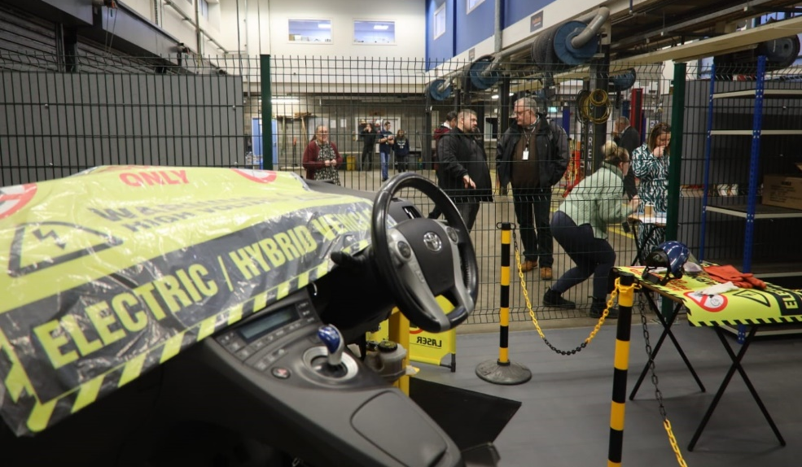
As the number of Electric and Hybrid vehicles continues to rise, Castleford College is helping professionals and individuals stay ahead of the curve with its brand-new range of Electric and Hybrid vehicle courses.
The programmes, which are due to start in January 2023, are designed to provide the knowledge and training needed to work with Electric and Hybrid vehicles safely and efficiently.
Covering a variety of areas related to maintenance and repair of systems and components found in vehicles, the courses are ideal for those aspiring to or currently working in the growing Electric and Hybrid vehicle sector.
Awarded by the Institute of Motor Industry (IMI), the programmes range from Level 1 up to Level 4 and are internationally recognised qualifications.
Gareth Mitchell, Curriculum Development Manager for Automotive at Castleford College, said: “Whether you are a mechanic, a first responder or a car salesman, Electric and Hybrid vehicles are becoming a part of everyday life. As Electric and Hybrid vehicles have unique mechanical and electrical arrangements, it’s critical that those working with these vehicles have the training and specialist skills needed to operate and fix them safely and efficiently.
“With the introduction of these new courses, we can help everyone adapt and stay ahead of the curve when it comes to Electric and Hybrid vehicles. Regardless of whether you are a beginner hoping to raise your awareness, or if you are wanting to upskill to work with and repair high-voltage vehicle systems and components, there is something for everyone,” added Gareth.
According to IMI’s latest data, the first six months of 2022 saw the highest number of technicians take an Electric Vehicle qualification that is eligible for IMI TechSafe™ recognition, since its introduction in 2016.
The range of courses include a Level 1 Award in Electric/Hybrid Vehicle Awareness, Level 2 Award in Electric/Hybrid Vehicle Routine Maintenance Activities, Level 3 Award in Electric/Hybrid Vehicle System Repair and Replacement and Level 4 Award in the Diagnosis, Testing and Repair of Electric/Hybrid Vehicles and Components.
As part of the Government’s Strategic Development Fund, Wakefield College is set to receive £800K in capital and revenue investment to invest in its electric vehicle equipment – which will see students learn on brand-new Electric and Hybrid Vehicle training rigs.
Employers from across the region were recently invited to the College to see the training rigs and its state-of-the-art Automotive facilities as part of its Electric and Hybrid Vehicles launch event.
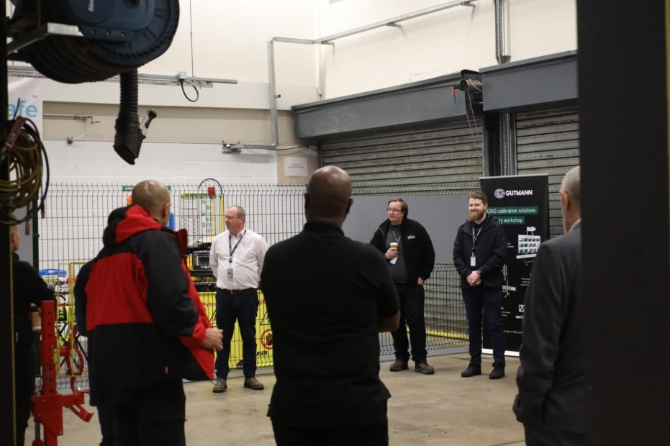
Employers from across the region attended the Electric and Hybrid Vehicles launch event
The part-time courses will be delivered on a Monday and Tuesday at Castleford College, within its Automotive centre.
The department has also partnered with Prosol UK, which provides Motor Trade equipment and tools, to provide students with a discount on its Electric Vehicle safety products.
Find out more about the courses, at: https://www.wakefield.ac.uk/study-with-us/
ENDS
Organisation: Selby College
Press Contact: Callie Sowerby
Email: sowerbyc@selby.ac.uk
Website: www.wakefield.ac.uk
###
About Castleford College
Castleford College has been passionately serving the needs of vocational learners across the Wakefield District since its campus was first built in 2009.
Delivering a variety of T Levels, Vocational courses, Apprenticeships and part-time adult and professional courses, the College provides an exceptional learning environment for learners studying Childcare, Construction, Engineering, Hair and Beauty, Health and Social Care, Motor Vehicle and more.
The College also provides degree-level Engineering and Construction programmes with the University Centre at the Heart of Yorkshire Education Group, which has been delivering a variety of degree-level programmes in partnership with leading award bodies and universities for more than 20 years.
Castleford College was officially granted College status in March 2022 following the merger between Selby College and Wakefield College - forming the Heart of Yorkshire Education Group.

