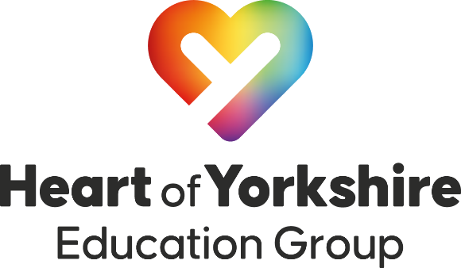
28th June 2023
Heart of Yorkshire Education Group launches Skills Bootcamp in Carbon Capture and Storage
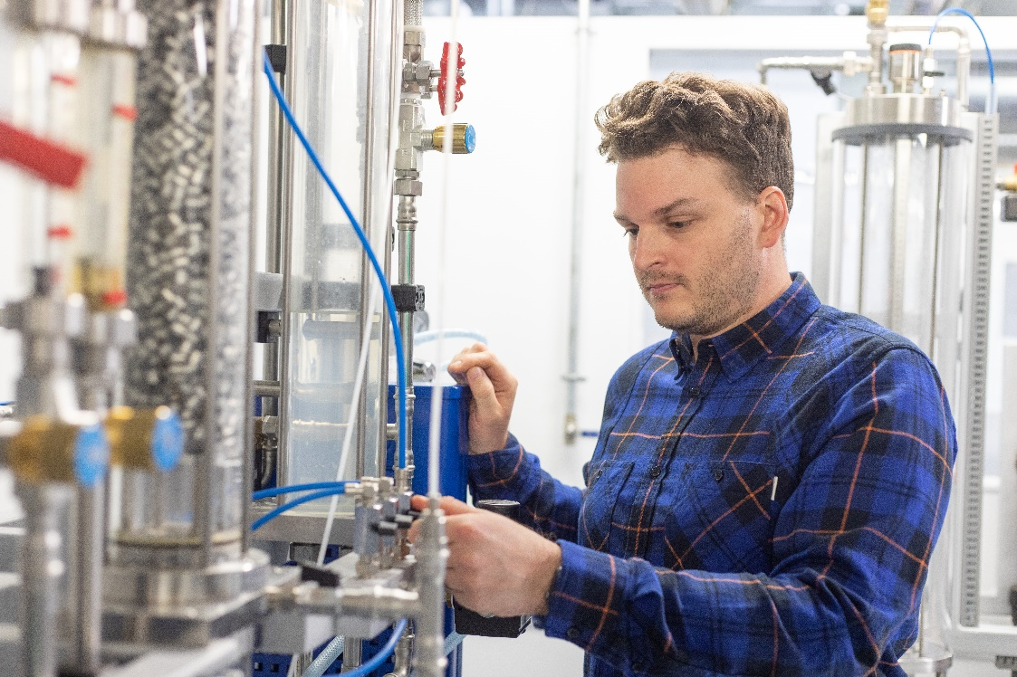
In response to the rising demand for green skills, the Heart of Yorkshire Education Group has launched a first-of-its-kind Skills Bootcamp in the Principles of Carbon Capture and Storage.
Formed in partnership with the Department for Education and the York & North Yorkshire Local Enterprise Partnership (Y&NY LEP), the Skills Bootcamp in the Principles of Carbon Capture and Storage aims to provide learners with the higher-technical skills and knowledge to operate this climate-saving technology.
These acquired skills are at the forefront of cutting edge technology and practice, and are likely to be in high demand in line with the UK’s net zero strategy.
David White, Head of Regional Partnerships and Projects at the Heart of Yorkshire Education Group, said: “As the UK continues to drive forward its plans for de-carbonatisation of all industries by 2050, Carbon Capture and Storage technologies are paving the way for this change. However, to make this a reality, businesses require a highly-skilled workforce with the training and knowledge needed to operate climate-saving technologies such as this.
“The Skills Bootcamp in the Principles of Carbon Capture and Storage is a great opportunity for businesses looking to implement Carbon Capture projects or to adapt the technology for other applications into their operations, which will in turn create new roles, responsibilities and opportunities for their staff, whilst putting businesses at the forefront of the green revolution,” David added.
Steve Butler, Engineering Lecturer at the Heart of Yorkshire Education Group, added: “What’s fantastic about Carbon Capture and Storage is that it can be applied to a range of different use cases and at different scales. So many businesses distribute heat as part of their day-to-day operations – whether that’s a fish and chip shop, a hairdressing salon, a laundrette or a large-scale manufacturer; this technology provides a way for businesses, small or large, to capitalise on re-distributing this heat - which is vital during the energy crisis we are facing.”
The launch of the Skills Bootcamp comes following a successful pilot project with Drax Group, which is developing the vital negative emission technology bioenergy with carbon capture and storage (BECCS) at its power station near Selby.
The programme will cover a range of carbon separation processes including adsorption, heat recovery, heat exchangers, heat pumps and more.
Helen Simpson OBE, Chair of the York & North Yorkshire Local Enterprise Partnership, said: “We’re delighted to be working with partners such as the Heart of Yorkshire Education Group to deliver these Skills Bootcamps, which will help meet regional skills gaps, increase job opportunities and create a greener economy. By providing businesses in the region with the skillset to work on crucial green technologies, this will enable the region to play a vital role in helping the UK meet its net zero targets.”
Skills Bootcamps are part of the Government’s Lifetime Skills Guarantee and are free, flexible courses of up to 16 weeks, giving people the opportunity to build up sector-specific skills and fast-track to an interview with a local employer.
Eligible for participants over 19, the Skills Bootcamp is a five-week programme which will run one day a week at Selby College from week commencing 10th July 2023.
The Group is also expanding its course offering to include brand-new programmes in Heat Recovery and Transfer.
To find out more about the Skills Bootcamp in the Principles of Carbon Capture and Storage programme, please visit: https://www.selby.ac.uk/courses/skills-bootcamp-carbon-capture-and-storage--level-3
To find out more about Skills Bootcamps, visit: https://www.gov.uk/government/publications/find-a-skills-bootcamp/list-of-skills-bootcamps
ENDS
Organisation: Heart of Yorkshire Education Group
Press Contact: Callie Sowerby
Email: sowerbyc@selby.ac.uk
Website: www.heartofyorkshire.ac.uk
###
About the Heart of Yorkshire Education Group
The Heart of Yorkshire Education Group serves the education and skills needs of the Yorkshire region from its Colleges in Castleford, Selby and Wakefield.
The Group was formed following the merger of Selby College and Wakefield College and the formation of Castleford College on 1st March 2022.
The Group offers an expansive range of post-16 provision, apprenticeships, higher education, adult qualifications and distance learning, through its wide variety of full and part-time courses. It also works closely with employers locally, regionally and nationally to deliver work-based training programmes to meet existing and future skills shortages.

Across its three Colleges, the Group serves over 9,000 students including full-time, Higher Education and Apprentices. With a combined turnover of £36 million, the Group currently employs more than 800 teaching and support staff.
www.heartofyorkshire.ac.uk

